Match the book to the name of the writer:

1.History of the Slavs and Bulgarians

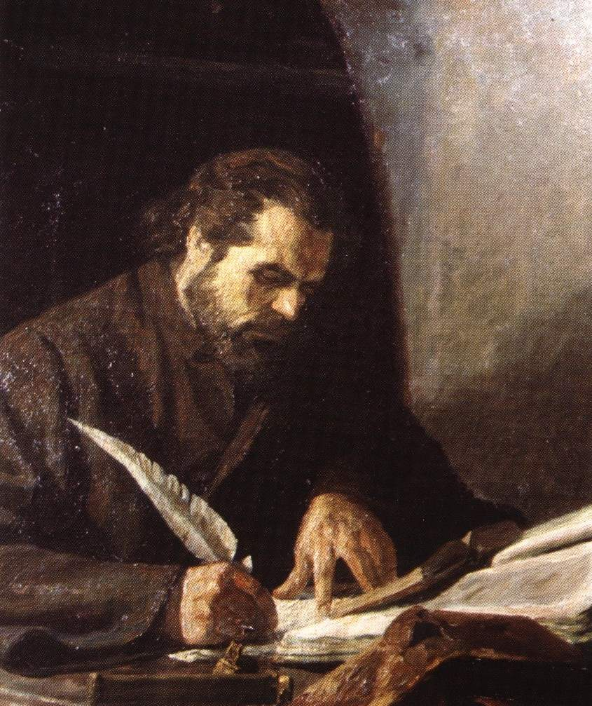

a.Paisii Hilendarski

b.Ivan Vazov

c.Hristo Botev

d.Jordan Jovkov

Answer a.

2. Memories of the Bulgarian Uprisings

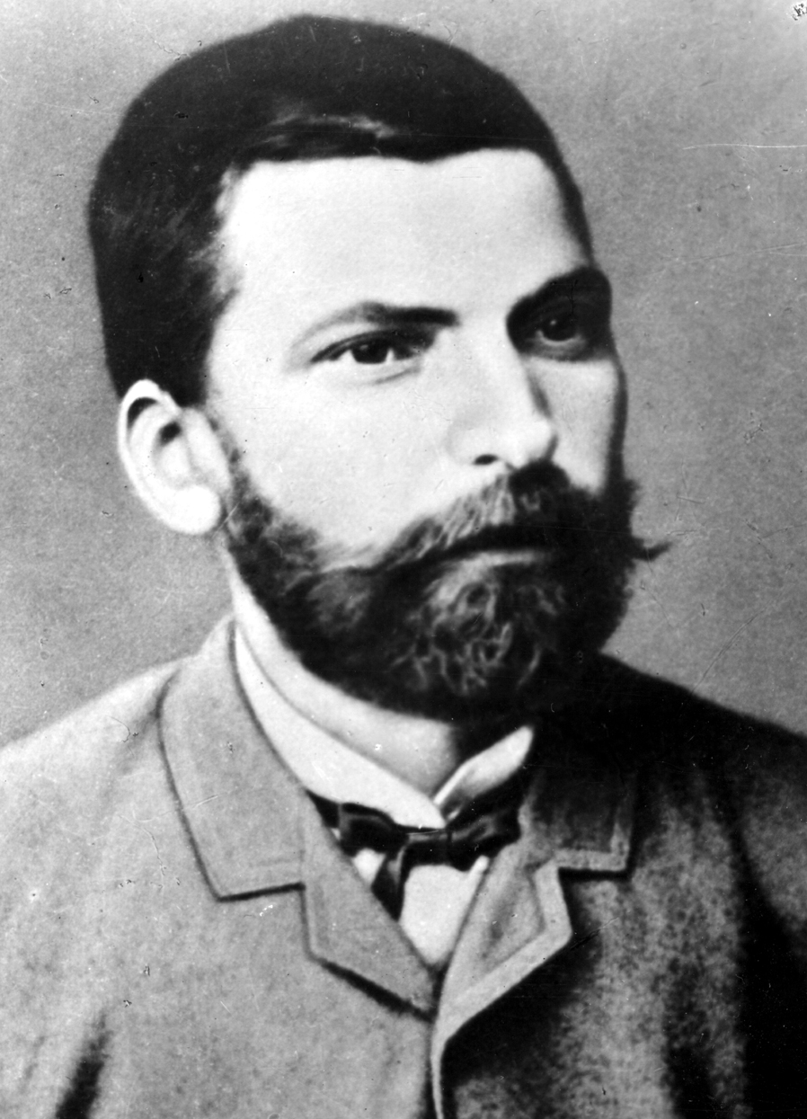

a. Aleko Konstantinov

b.Ran Bosilek

c.Zahari Stoyanov

d.Hristo Botev

Answer: c

3. Under the Yoke

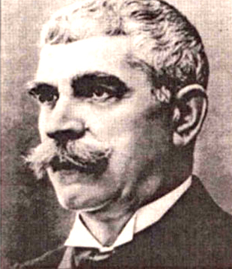

a. Dimitar Dimov

b. Dimitar Talev

c. Peyo Yavorov

d. Ivan Vazov

Answer: d

4. Bai Ganyo: Incredible Tales of a Modern Bulgarian

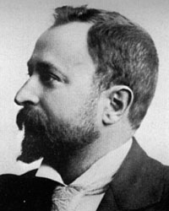

a. Hristo Smirnenski

b. Aleko Konstantivov

c. Nikolay Liliev

d. Dora Gabe

Answer: b

5. Tobacco

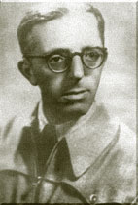

a. Hristo Smirnenski

b. Jordan Jovkov

c. Dimitar Dimov

d. Elisaveta Bagriana

Answer: c

**Sources:**

**Paisii Hilendarski**

<http://bg.abdmp.eu/250-godini-istoriq-slavqnobulgarska/>

**Zahari Stoyanov**

<http://bezlogo.com/2012/03/zahari-stoyanovvkato-narod-nie-mozhem-da-se-gordeem-tche-vsitchkite-ni-narodni-deyateli-sa-bile-protiv-ofitsialna-rusiya-v.html>

**Ivan Vazov**

<http://dichev.com/blog/bulgarian/ivan-vazov/opalchencite-na-shipka/>

**Aleko Konstantinov**

<http://bg.wikipedia.org/wiki/%D0%90%D0%BB%D0%B5%D0%BA%D0%BE_%D0%9A%D0%BE%D0%BD%D1%81%D1%82%D0%B0%D0%BD%D1%82%D0%B8%D0%BD%D0%BE%D0%B2>

**Dimitar Dimov**

<http://www.slovo.bg/showbio.php3?ID=93>